

**Oatile Morudu**

**ST10488465**

**WEDE5020**

**Part 1 proposal 2**

**Table of content**

1. Organization overview
2. Website goals and objectives
3. Features and functionalities
4. Design and user experience
5. Technical requirements
6. Timelines and milestones
7. Budget
8. References

**Organization Overview**

**Name:** CustomPrints

**History:** Printing things on products and objects has been around for many years and it all started in China around the 1900.

**Mission statement**

* To give people and businesses more power by making high quality, personalized printed products that spark creativity, boost brands, and brings ideas to life, one print at a time.

**Vision**

* To be one of the biggest leaders in personalized product printing, known for being innovative, excellent, and making custom design available to everyone.

**Target market**

* Small businesses and startups need branded goods and promotional products like pens, mugs, and t- shirts.
* Normal customers and gift givers are able to customize presents for holidays, anniversaries, and birthdays. They could be very sentimental and unforgettable presents.

**Website goals and objectives**

* Increase social media following
* Within the first 6 months, at least generate R10 000 in revenue
* Within the first 3 months, reach 500 orders
* Answer all customers within the day

**KPI’s**

* Website traffic
* Run monthly promotions and influencer campaigns to market the store.
* Gain a very strong following on Instagram and Tiktok following. Around 10 000 followers in the first year
* I would like the website to generate at least R20 000 - R50 000 in revenue within the first year.
* Achieve 1500 sales within 6 months after the launch of the store.

**Features and functionality**

* Users may store designs and monitor orders by creating accounts
* Showcase that may be customizable, such as bags, T-shirts, mugs, etc
* Allow the users to add pictures or logos, include personalised text, select the fonts, colours, and placement, view the finished result in real time.
* Add multiple items
* Secure payment gateways

**Design and user experience**

**Colour scheme:** I am going to use red and white.

**Typography:** I am going to use open-sans and sans-serif to give the website a more aesthetic look.

**Layout and design**

* Simple, present day, and minimalistic
* Uses white and red to convey clarity and trust
* A welcoming atmosphere with rounded components
* A worldwide theme with delicate patterns or icons
* Search bar, Account, Cart icons and logo

**User experience consideration**

* Have a clear menu structure
* A single click “add to cart”
* Persistent shopping cart(incase users leave the site and want to come back)
* Have clear product filters
* Have fast loading times ( Optimizes fonts, images and scripts)
* Have safe and secure payment options
* Show estimated delivery times by location

**Wireframes**

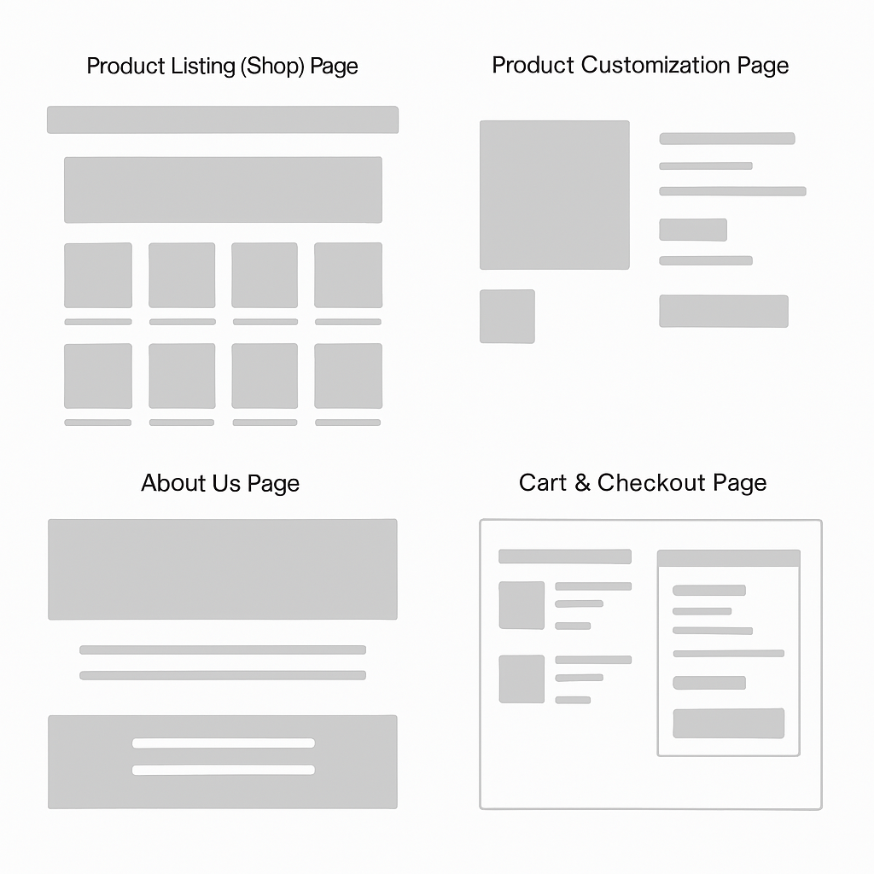

**Technical requirements**

* Domain: https//: Nations2Nations . com
* Fast performance
* SSL and email included

**Programming languages and frameworks**

* HTML, CSS, and JavaScript
* For database i will use MySQL
* For Payments i will use PayPal, Credit/Debit cards

**Timeline**

| **Week** | **Description** | **Task** |
| --- | --- | --- |
| Week 1 | Research and planning | Finish off the proposal and do continuous research |
| Week 2 | Continued research (POE part 1 due) | Regards the website structure and planning (including HTML structure) |
| Week 3 | Coding | Coding HTML website without making it look nice |
| Week 4 | CSS Design | Making the website look more aesthetically pleasing (using CSS) |
| Week 5 | Testing | I will test the website and see if it actually works |
| Week 6 | JavaScript | Enhancing the JavaScript to allow the navigation to be better |
| Week 7 | SEO | I will Search Engine Optimizing my website so it is easily accessible |
| Week 8 |  |  |

**Budget**

| **Item** | **Budget** |
| --- | --- |
| * Domain | R300-R500/year |
| * Host | R1000-R2000 |
| * SSL Certificate | R500 |
| * Payment gateway | R500 |
| * Marketing | R1000-R5000 |

**References**

* blog.converted.in. (2022). *8 Ways To Determine Ecommerce Target Audience For Your Store*. [online] Available at: https://blog.converted.in/en-us/blog/8-ways-to-determine-ecommerce-target-audience-for-your-store.
* ‌AgencyAnalytics. (n.d.). *12 Ecommerce Goals That Drive Client Success*. [online] Available at: https://agencyanalytics.com/blog/ecommerce-goals.
* ‌Softermii. (n.d.). *Most Popular Programming Languages and Frameworks for 2023*. [online] Available at: https://www.softermii.com/blog/top-programming-languages-and-frameworks-for-software-development.